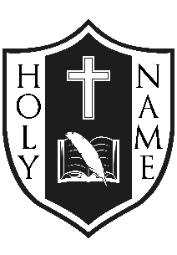
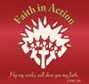
Holy Name
Catholic School
November, 2018
Greetings: Faith in Action: Make a Difference means serving as peacemakers. Peacemakers can be found in the class, schoolyard, hallways, on the bus, and at home. Together, we all can be peacemakers.
Encourage one another;
Build one another up.
Be at peace among
yourselves…
Always seek to do good
To one another…
Rejoice always,
Pray constantly,
Give thanks in all
circumstances;
For this is God’s will
In Christ Jesus for you.” 1 Thess. 5:11, 13, 15-18

God Bless,
Mrs. L. McDonald

There will be a Remebranace Day Prayer service in the school gym on Fri. Nov. 9th @ 10:45. Recess will be adjusted so we can acknowledge silence at 11:00 AM. Parents are invited!
The next school Mass is scheduled for Thurs. Nov. 22 at 9:30 and the theme for the mass will be Peace. Please plan to join us!

Caring and Safe Schools:
SchoolMessenger: Is an automated system that allows the school to send information by phone and/or email to families. A consent form was sent home and the service can always be disconnected by you if requested.
Lockdown Drill is scheduled for Nov. 21/18 in the morning. Each school in the ALCDSB is required to have a Fall and Spring Lockdown drill. Phones and doorbell will not be answered during the drill.
Spring and Fall are the seasons when HEAD LICE commonly infest school children. Please check your child’s head weekly. If you find evidence of head lice or nits, information about how to remove is available from your family doctor, school, health unit and most pharmacies. Information pamphlets are also available at the school and/or on the Board’s website.
Concussions – Policy and Procedures
Students who may encounter head trauma during sports or from falls either at school or outside of school need to be taken very seriously. As a result, there are procedures and follow up required at the school level when this happens. There are necessary information forms required to be completed. Contact the school if your child has been identified as having experienced a concussion.
Progress Reports and Parent-Teacher-Student Conferences: Progress Reports are scheduled to go home on Tues. November 06, 2018 for students in K to 8. A student’s Progress Report provides a formal opportunity for classroom teachers to communicate student progress, goals and next steps to parents and guardians. During each school year there are many opportunities for parents, teachers and students to discuss, both formally and informally, the progress of learning. Communication is particularly appropriate and meaningful after each reporting period. Conference request forms have already been sent home with students. Confirmation of scheduled times will be sent home with each child by his/her teacher.
FUN FRENCH FACT
DID YOU KNOW?
Approximately 60% of English words are of either French origin or Latin origin words that also exist in French!
http://bit.ly/2PkHOCX
Encourage your child to be a lifelong learner of French!
Sports Update:
Volleyball practices have begun in preparation of the upcoming tournaments. Special thanks to Mr. Gaudet, Mr. Archer and Mr. Waller who are serving as coaches.
ECO School Update:
A battery bucket will be located in the main hallway. The ECO Team is collecting all household batteries, (AAA, AA, C, D). *Recycling batteries keeps heavy metals out of our landfills.
“E-NEWS”: Please register for Newsletters to be sent via email. Simply go to alcdsb.on.ca; find Holy Name Catholic School and scroll to the link to register. An email will be sent to verify your request and then monthly Newsletters will come to you!
Catholic School Council Update
Thank you to all who participated in the Family Halloween Event Fundraiser! Your support is always appreciated. Funds raised exceeded $500 and will go toward the School Yard Enhancement project. 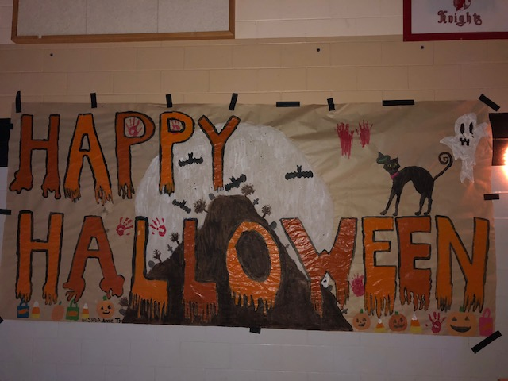
Minutes from meetings are posted on the school website once they are available from Council.
All parents are invited to attend the next School Council meeting scheduled for: Wed. Nov. 21, 2018 from 6:30 – 8:00 PM. The Catholic School Council has invited a Guest Speaker for the first half hour, Denise Van de Engel, founder of the ADHD Parent Support Group in Kingston.
Upcoming Events:
Aim to track the happenings of Holy Name on our School’s Webpage!
School Retake Photos: Thurs. Nov. 09, 2018, in the afternoon.

